Laboratory of Wood Technology

Report No: | 11-40/EK/1423-2
Date of issue: | 28.10.2022
Pages: | 3
Customer: | Standwood OÜ
Customer address: | Sõeru tee 11, Alliku küla, Saue vald, 76403
Customer contact: | Kaarel Tali
Test subjects: | Interior cladding board, finger jointed and laminated with veneer
Test method: | EN 314-1
Testing objective: | Testing the durability of glue joints in finger jointed interior cladding boards
Test specimen(s) description and marking used in current report:

Appendices:
Appendix 1 | EN 314-1 Test results for glue joints in interior cladding board

Given report shall not be reproduced without written approval of the laboratory. | Approved by:  Jaan Kers, PhD  Head of Laboratory of Wood Technology
APPENDIX 1.
TALLINN UNIVERSITY OF TECHNOLOGY | DEPARTMENT OF MATERIALS
AND ENVIRONMENTAL TECHNOLOGY
Teaduspargi 5  12618 Tallinn, Estonia  Registry code 74000323 | Phone +372 620 2910  E-mail jaan.kers@taltech.ee  www.taltech.ee

Specimen(s) description

Finger jointed interior cladding board with veneer lamination.
Wood species: alder.
Bond strength specimen cut out from boards: 12 mm x 25 mm x 170 mm, 14 pcs .
Shear area: 25 x 25 mm.

Test description

Test severity classification:
EN 314-2 Plywood – Bonding Quality – Part 2: Requirements; class 3: – non-covered exterior

Specimen pre-treatment sequence:
- Immersion for 24h in water at ( 20 ± 3) °C.
- Immersion for (72 ± 1) h in boiling water, followed by cooling in water at (20 3) °C for at least 1h.

Tensile test for bond strength determination after pre-treatment between the top veneer layer and finger jointed structure underneath.

Test parameters

Tester(s) | Margus Kangur, technician
Test Machine | ZwickRoell Z050
Test type | EN 314-1
Test date | 27.10.2022

Test results

The specimen bonding requirements passed the test according to EN 314-1, obtaining plywood use class no 3: non-covered exterior conditions. No delamination occured during pre-treatment – finger joints visually sound.
Average bond strength 2,5 ± 0,5 N/mm².
TALLINN UNIVERSITY OF TECHNOLOGY |
DEPARTMENT OF MATERIALS AND ENVIRONMENTAL TECHNOLOGY

Table 1. Test results 314-1
Specimen ID | Maximum load, N | Bond strength, N/mm²
Specimen 1 | 1604 | 2,6
Specimen 2 | 1461 | 2,3
Specimen 3 | 1406 | 2,2
Specimen 4 | 1110 | 1,8
Specimen 5 | 1361 | 2,2
Specimen 6 | 1913 | 3,1
Specimen 7 | 1984 | 3,2
Specimen 8 | 1528 | 2,4
Specimen 9 | 1142 | 1,8
Specimen 10 | 1863 | 3,0
Specimen 11 | 2118 | 3,4
Specimen 12 | 1318 | 2,1
Specimen 13 | 1165 | 1,9
Specimen 14 | 1522 | 2,4
Average | 1535 | 2,5
Standard deviation | 324 | 0,5

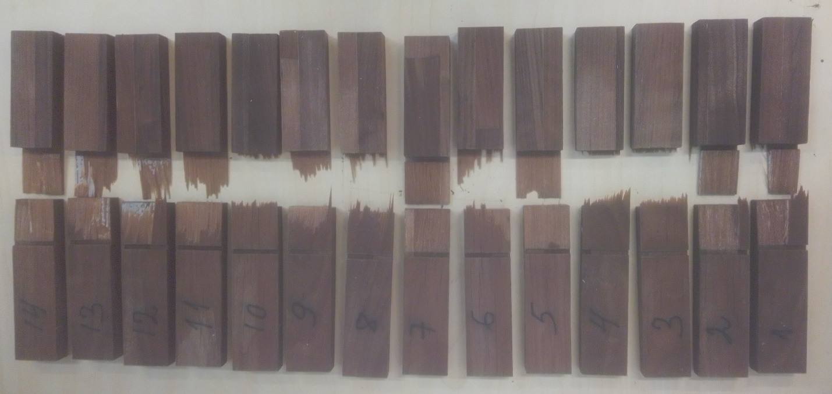
Figure 1. Specimen after testing
TALLINN UNIVERSITY OF TECHNOLOGY |
DEPARTMENT OF MATERIALS AND ENVIRONMENTAL TECHNOLOGY

